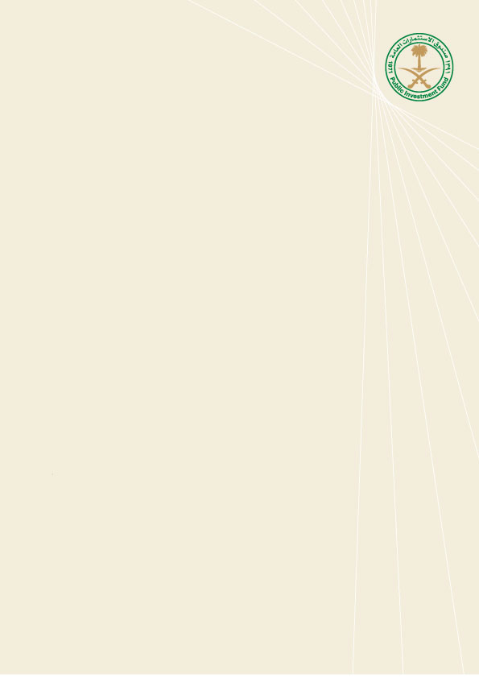

**UAT Guidelines**

March 8, 2021

**Version Approval Sheet**

|  |  |  |  |  |
| --- | --- | --- | --- | --- |
|  | **Name** | **Designation** | **Date** | **Signature** |
| **Initiated by** |  |  |  |  |
| **Endorsed by** |  |  |  |  |
| **Approved by** |  |  |  |  |

**Amendment History Sheet**

|  |  |  |  |  |  |
| --- | --- | --- | --- | --- | --- |
| **Amendment No.** | **Section No.** | **Date of Revision** | **Details of Amendment** | **Originated By** | **Remarks** |
|  |  |  |  |  |  |
|  |  |  |  |  |  |
|  |  |  |  |  |  |
|  |  |  |  |  |  |

**List of Applicable Laws, Regulations and Guidelines**

|  |  |  |  |  |
| --- | --- | --- | --- | --- |
| **Sr No.** | **Name** | **Authority** | **Law Reference** | **Date** |
|  |  |  |  |  |
|  |  |  |  |  |
|  |  |  |  |  |

Contents

Section A – Document Overview 4

1. Introduction 4

2. Purpose 4

3. Scope 4

4. Responsibility 4

5. Review and Update 4

6. Effective Date 5

Section B – Guidelines 5

7. Definitions : 5

8. Objectives of UAT 6

9. Stakeholders – Roles & Responsibilities 6

10. Test Planning and test design 7

11. Test Execution 8

12. Framework 12

13. Governance & Escalation 13

14. Vendor requirements 13

15 Appendices 14

Appendix 1: Abbreviations 14

Appendix 2: Sign-off document 15

Appendix 3: Tractability matrix 16

Appendix 4: Test Plan Document 16

Appendix 5: Test scenarios and test cases templates 16

Section A – Document Overview

# Introduction

As part of increasing PIF’s maturity and since one of the critical activities in any IT solution development is the User Acceptance Testing (UAT), at which the user tests the system to ensure it is error free and that it delivers what was it designed for, this document has been developed to ensure practicing UAT at high level of quality.

# Purpose

* 1. The purpose of this Document is to define and communicate the UAT Guidelines applicable to all IT Projects of the Public Investment Fund (PIF or the Fund). These Guidelines contained in this document are intended to serve as an operational guideline to the management and staff involved in the IT Projects.
  2. All UAT Stakeholders are expected to fully understand, and follow the guidelines contained in this document in the UAT execution’s activities.

# Scope

* 1. The content of these guidelines are applicable to all PIF IT solutions’ UATs.
  2. The content of these guidelines are not applicable to any other testing e.g. (stress testing, vulnerability testing, system integration testing. Etc.)
  3. The content of these guidelines are not applicable to UATs in the agile methodology.

# Responsibility

* 1. The PMO and IT Departments are the custodian (Owner) of these Guidelines. They are expected to ensure that these guidelines are a true and accurate representation of the applicable guidelines and that it is kept up to date at all times.
  2. The Head of the IT Department is responsible for the implementation of these Guidelines across the Fund.
  3. The contents of these Guidelines are applicable to all of PIF’s IT Solutions. Any exceptions to the guidelines contained herein shall be approved by the PMO and IT Heads.

# Review and Update

* 1. These Guidelines shall be reviewed on an annual basis, or more frequently if required, in accordance with PMO and IT Departments.
  2. The approval of both PMO & IT Heads must be obtained in the event of any changes or updates that may occur in the Guidelines after taking the necessary recommendations

# Effective Date

* 1. These guidelines shall be effective from the date of approval by the PMO and IT Heads.

Section B – Guidelines

# Definitions :

* 1. **User Acceptance Testing** (UAT) is a type of testing performed by the end user or the client to verify/accept the software system before moving the software application to the production environment.The main purpose of UAT is to validate end-to-end business flow. User Acceptance Testing is carried out in a separate testing environment.
  2. **Acceptance Criteria**: It is the conditions that a software product must satisfy to be accepted by a user, customer or other stakeholder.
  3. **Test Scenario**: A test scenario is defined as any functionality that can be tested. It is also called Test Condition or Test Possibility.
  4. **Test Case** : A test case is a set of actions executed to verify a particular feature or functionality of your software application
  5. **Traceability matrix**: a sheet that will link the requirement with the test scenarios and the test scenario with test cases, the main purpose for this sheet is to make sure we have a 100% test coverage (See appendix 3)

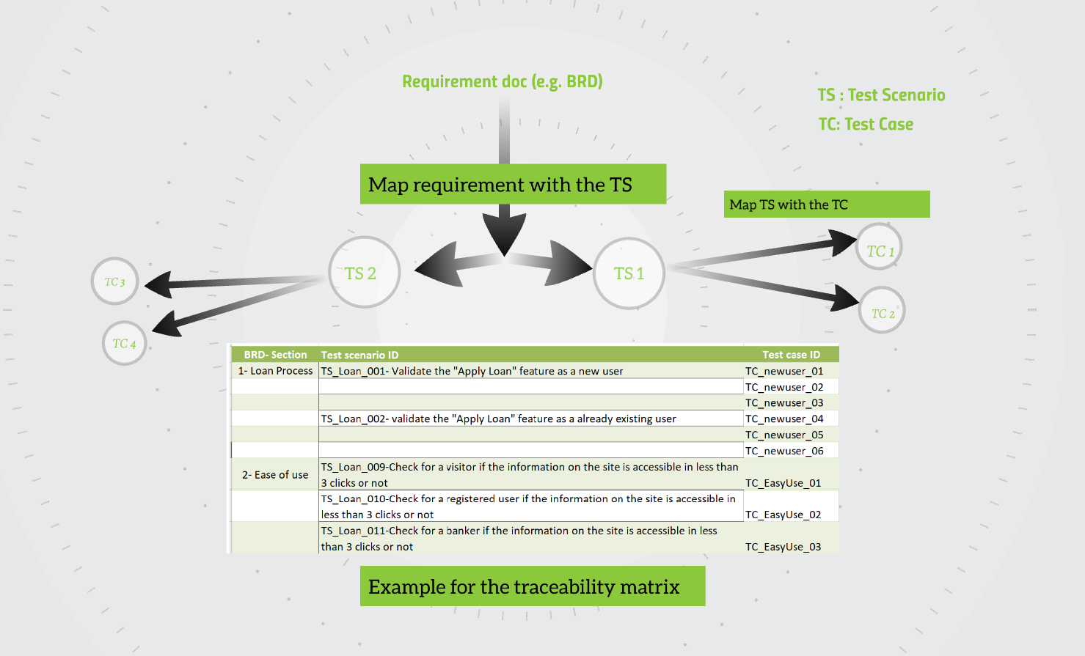

(**Traceability matrix 7.5)**

# Objectives of UAT

* + - Confirm that the system meets the agreed-upon criteria.
    - Identify and resolve discrepancies between the requirement and the SUT (System under test), if there are any.
    - Determine the readiness of the system for cut-over to live operations. The final acceptance of a system for deployment is conditioned upon the outcome of the functional acceptance testing. The UAT team will generate multiple documents such as test plan, test scenario (to be verified only by the team) in order to generate test closure report .After or in parallel with the UAT activities other types of testing can be conducted such as security testing / load testing and others.
    - Check whether Application functionality is working as expected without any error or bugs in test environment.

# Stakeholders – Roles & Responsibilities

|  |  |  |
| --- | --- | --- |
| Stakeholder | Role | Responsibilities |
| PMO | Project Manager | * Manage testing activities * Facilitate testing and communication among testing team members * Communicate overall status with the key stakeholders * Assure testing documentation |
| Business Owner | Approver | * Approve the UAT Sign-off |
| Business Team | Tester | * Review and approve Test cases/scenarios * Attend all scheduled test sessions * Test all assigned scenarios * Provide detailed description about the findings (if any) * Validate the UAT |
| IT | Technical Lead | * Prepare test environment. * Create a comprehensive set of test criteria, scenarios and cases from technical point of view. * Support testers in performing test scenarios by providing test data or executing the technical test cases. * Resolve the technical issues. * Ensure performing the security testing within the organization’s security standards. * Ensure performing the load testing on the application (if needed) testing within the organization’s standards.   Vendor’s delivery responsibilities:   * To insure fixing the raised issues in a timely manner. |
| IT | QA | * Prepare test plan document. * Coordinate the testing activities between the stakeholders. * Write test scenarios / test cases from QA point of view. * Review test scenarios/ test cases provided by the vendor and the stakeholders. * Execute, manage and follow up on all testing activities (Smoke, functional, UAT and regression testing). * Provide closure report for the testing to the involved stakeholders. * Approve the UAT Sign-off. |

# Test Planning and test design

* 1. Prerequisites for test planning and design:
* Final version of the Requirement document(s)
  1. Steps to fill the test plan
* Analyse the requirement: QA team will start reviewing the requirement (BRD ,SSD … ) and raise the concern(s) to the stakeholders (UX, missing or unclear requirement)
* Define what is in scope / out of scope for the testing.
* Schedule & Estimation: Review the test cases in order to estimate the effort for the execution
* Fill the test plan document accordingly. (Refer to appendix 4)
  1. Test scenarios
* A test scenario contains high-level documentation that describes an end-to-end functionality to be tested.
* It focuses on more "what to test" than "how to test".
* Test scenarios are a one-liner. Therefore, there is always the possibility of ambiguity during the testing.
* Test scenarios are derived from test artifacts like BRS, SRS, etc.
* Test scenarios are high-level actions.
* Comparatively less time and resources are required for creating & testing using scenarios.
* Test scenarios will be provided by the relevant stakeholders.
* QA team will review the TSs and will provide the feedback, then the relevant stakeholders will update the same according to QA feedback.

(Refer to appendix 5)

* 1. Test cases
* Test cases contain definite test steps, data, and expected results for testing all the features of an application.
* A complete emphasis on "what to test" and "how to test.”
* Test cases have defined a step, pre-requisites, expected result, etc. Therefore, there is no ambiguity in this process.
* Test cases are mostly derived from test scenarios. Multiple Test cases can be derived from a single Test Scenario
* It helps in exhaustive testing of an application
* Test cases are low-level actions.
* More resources are needed for documentation and execution of test cases.
* Relevant stakeholders will provide the test cases to QA team, QA team will review it and provide the feedback so the relevant stakeholders can update the test cases accordingly.

(Refer to appendix 5)

* 1. Deliverables before starting the UAT:

Test deliverables are provided before testing phase.

1. Test plan document.
2. Test cases , Test scenario and traceability matrix (to be provided by the relevant stakeholders and the QA team will review and provide the feedback)

# Test Execution

* 1. Prerequisites to start the testing:
* Test data : for each test case the test data should be provided / prepared on UAT environment and to be provided by the relevant stakeholders (if we’re dealing with a 3rd party ;a request should be sent to the team to provide the test data in advance)
* Test cases / scenarios should be finalized and sealed.
  1. Testing Types:

Testing Type is a standard test procedure that gives an expected test outcome. Each testing type is formulated to identify a specific type of product bugs. But, all Testing Types are aimed at achieving one common goal

“Early detection of all the defects before releasing the product to the customer”

Below we have mentioned the main types of testing that should be conducted on any coming project/change:

|  |  |  |  |
| --- | --- | --- | --- |
| S .No | Type | Description | Responsible stakeholders |
| 1 | Smoke testing | * Type of software testing that comprises of a non-exhaustive set of tests that aim at ensuring that the most important functions work. The result of this testing is used to decide if a build is stable enough to proceed with further testing. | QA |
| 2 | Functional testing | * To make sure the functionality of the system is working as expected by executing all the finalized test cases | QA |
| 3 | UAT | * To make sure the E2E scenarios and business logic is working as expected for a pre-defined scenarios | QA along with the business team |
| 4 | Regression testing | * This testing type needs to be conducted after we complete the UAT and the main purpose for it is to make sure the fixes from the raised bugs didn’t affect other functionality. | QA |

** Additional testing types may be required and that depends on the nature of the project.

* 1. UAT Entry criteria

Entry criteria for testing can be defined as “Specific conditions or on-going activities that must be present before a process can begin”.

**UAT prerequisites:**

* Identify the key stakeholders and their role in the testing (roles will be added in the test plan and UAT sign-off).
* Business requirements / project documents must be available and it should be finalized.
* Application Code should be fully developed and deployed to test environment rather than development and production.
* All the required testing types before the UAT phase should be completed and testing results should be shared with QA team from relevant stakeholders.
* For any business request that includes any change in the design or the business logic; an approval (business and **technical team) must be available and communicate it to all stakeholders, also the same changes should be reflected on the requirement.
* No Showstoppers or High defects still open.
* Traceability matrix for all testing should be completed
* Test Environment must be ready

** The approval from the technical team is required in order to check if the change is doable from the technical point of view.

On the below sections, we will go through the testing cycle starting from the smoke testing until the regression testing and be noted that the business involvement is only in the UAT stage and their support only needed with other testing types if required.

* 1. Smoke testing:

QA team will start the Smoke test once the build is deployed to test environment and based on the testing results the QA team will decide to accept the build or not into the testing environment.

* 1. Functional testing
* Relevant stakeholders will conduct the functional testing under UAT supervision.
* Each test case will be executed starting with the high priority cases.
* Functional testing results will be updated on the test execution log with the correct status such as (Passed, Failed, Blocked...)
* An evidence should be attached for each test case (Screenshots, videos or documents) for functional testing.
* Map defects to test cases in the log file and to communicate it to developer (Front end or backend teams’)
* Once the defect is fixed and assigned back to the testing team, the bug retesting will start and testing team will update the ticket status based on the testing results.
* Each end of day the vendor testing team should provide a daily status report contains (test cases executed, number of the raised issue(s), and number of retested bug for the day).
  1. UAT (User Acceptance Testing) process
* After the QA team confirms that the **entry criteria are filled and we can conduct the UAT activity with the business; the QA team will coordinate the testing with the business team.
* QA team will start executing E2E scenarios along with the business team.
* UAT results will be updated on the test execution log with the correct status such as (Passed, Failed, Blocked...)
* An evidence should be attached for each test case (Screenshots, videos or documents) for UAT.
* Map defects to test cases in the log file and to communicate it to developer (Front-end or backend teams’)
* Once the defect is fixed and assigned back to the testing team, the bug retesting will start and QA team will update the ticket status based on the testing results.
* Each end of day the QA team will provide a daily status report contains (test cases executed, number of the raised issue(s), and number of retested bug for the day).
* When all the test cases executed successfully based on the **exit criteria the QA team will notify the project manager in order to collect the signatures for the signoff.
* ** For more details regarding the entry criteria you may refer to section # 13 and for the exit criteria refer to section # 15
  1. Regression testing

The relevant stakeholder (Vendor / QA) will conduct the regression testing to make sure there will be no impact from the final round of testing and it should start after we fix all the open functional.

* 1. UAT exit criteria

An exit criteria is a set of accepted conditions or business rules which the functionality or feature should satisfy and meet, in order to be accepted by the Product Owner/Stakeholders.

1. 100% Test cases executed.
2. 95% pass rate of Test cases.
3. No open Critical and High severity defects.
4. 95% of Medium severity defects have been closed.
5. All remaining defects are either cancelled or documented as Change Requests for a future release.
   1. Test execution deliverables:

This stage comes after we complete the regression testing and the below deliverables should be provided by UAT team:

1. Defect Report: a document having a summary for the issues found during the UAT.
2. Test results: QA team will share the test results for the test cases/ test scenarios.
3. Test closure: Test Closure is a document that gives a summary of all the tests conducted during the software development life cycle, it also gives a detailed analysis of the bugs removed and errors found. In other words, Test Closure is a memo that is prepared prior to formally completing the testing process. This memo contains a report of test cases executed, type and number of defects found, the density of defects, etc.)
4. UAT signoff: A document to be signed by the business users along with their comments such as knows issues and then the QA team will add the same. See appendix 2

# Framework

Framework shown below is to highlight the major stages in the UAT activity as well as showing the major activities in each stage.

|  |
| --- |
| This framework is a first draft, and will be significantly reviewed and edited by PMO |

# Governance & Escalation

# Vendor requirements

15 Appendices

Appendix 1: Abbreviations

|  |  |
| --- | --- |
| **Terms** | **Definition** |
| PIF | Public Investment Fund |
| BOD | Board of Directors |
| MD | Managing Director |
| ACC | Audit & Compliance Committee |
| MC | Management Committee |
| DoA | Delegation of Authority |
| TS | Test Scenario |
| TC | Test Case |
| SSD | System Specification Document |
| BDR | Business Requirement Document |
| BA | Business Analyst |
| QA | Quality Assurance |
| UAT | User Acceptance Testing |
| E2E | End to End |

Appendix 2: Sign-off document

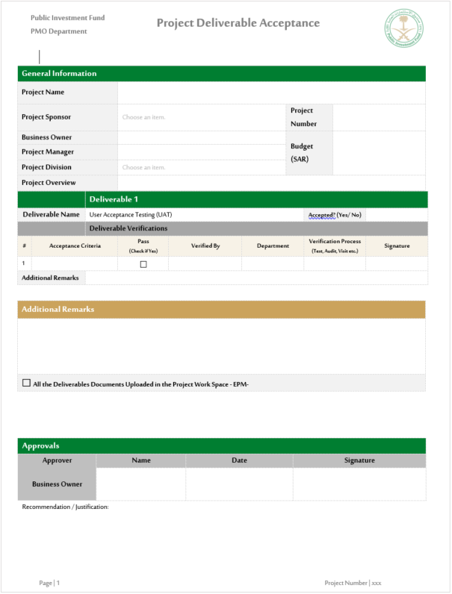

Appendix 3: Tractability matrix



Appendix 4: Test Plan Document



Appendix 5: Test scenarios and test cases templates

